Project#2

Project #2

Web

Data Analytics

• You are required to provide a ready ot use solution for IT team’s in organizations that want to digitize their support management system. The solution needs to use available open-source solutions that provide extensive features in cloud-native technologies.

• This project shoud also include basic open-source data analytics tools integrated

- https://github.com/jitsucom/jitsu

- https://github.com/odoo/odoo

- https://github.com/apache/superset

Odoo

Jitsu

Apache Superset

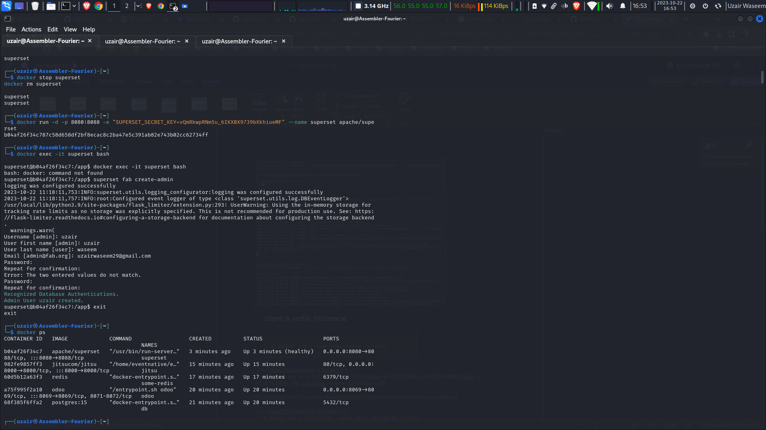

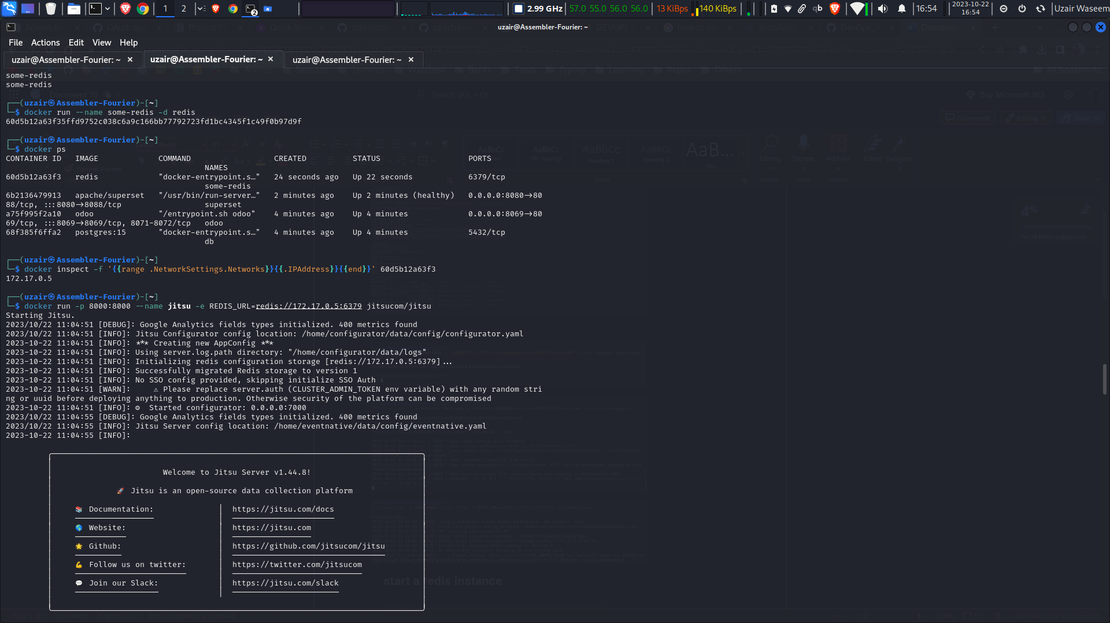

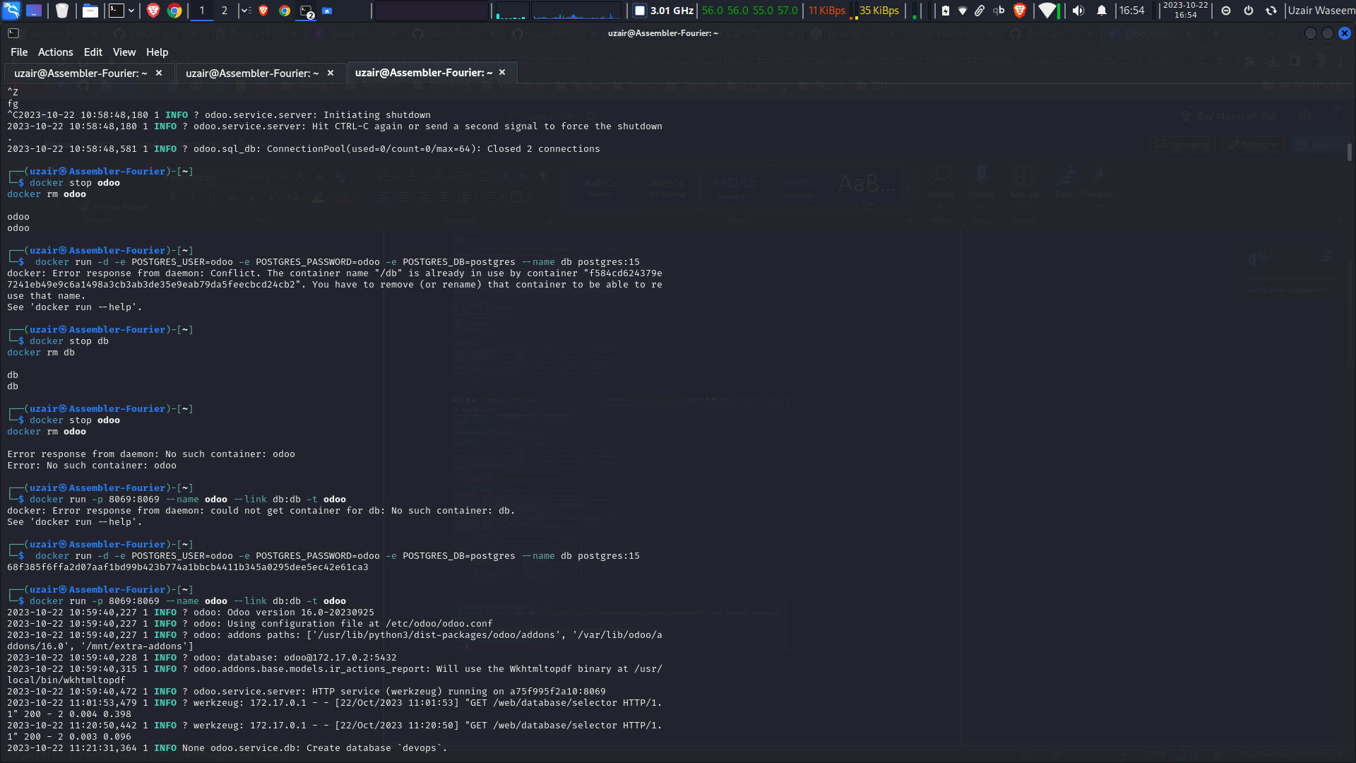

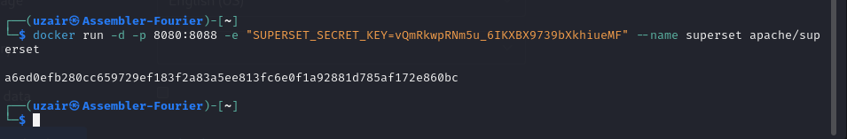

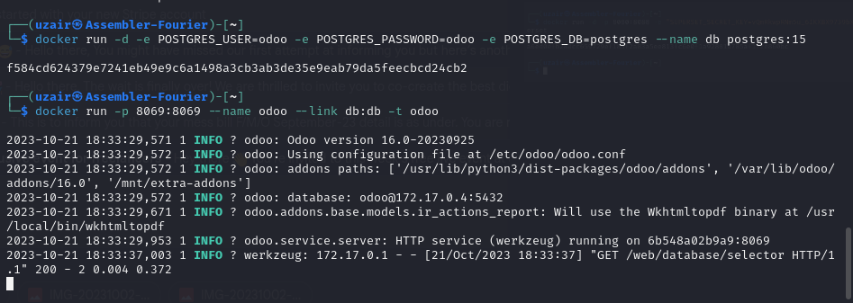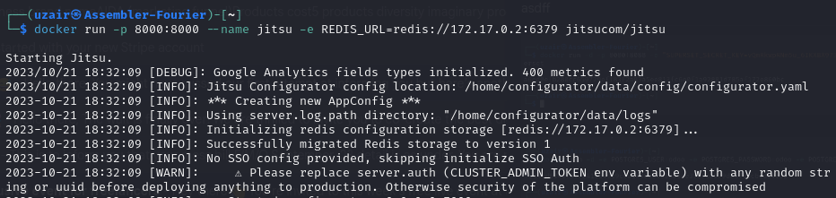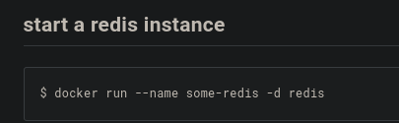  
   
┌──(uzair㉿Assembler-Fourier)-[~]  
└─$ docker run -d -e POSTGRES_USER=odoo -e POSTGRES_PASSWORD=odoo -e POSTGRES_DB=postgres --name db postgres:15  
  
f584cd624379e7241eb49e9c6a1498a3cb3ab3de35e9eab79da5feecbcd24cb2  
   
┌──(uzair㉿Assembler-Fourier)-[~]  
└─$ docker run -p 8069:8069 --name odoo --link db:db -t odoo   
  
  
  
  
  
  
  
 ┌──(uzair㉿Assembler-Fourier)-[~]  
└─$ docker run --name some-redis -d redis  
Unable to find image 'redis:latest' locally  
latest: Pulling from library/redis  
a378f10b3218: Already exists  
b266cd8112a6: Pull complete  
7ba86e6448de: Pull complete  
3aeb7c9e9a5f: Pull complete  
de3be2a98bda: Pull complete  
4f4fb700ef54: Pull complete  
98e18d21aa3b: Pull complete  
Digest: sha256:1f1bd4adf5dabf173b235ba373faef55f3ad53394791d1473763bf5a2181780d  
Status: Downloaded newer image for redis:latest  
172db6e6f0188a6684e01afaa3b441e7174df59f74189ede4f665ac6db7d7025  
   
┌──(uzair㉿Assembler-Fourier)-[~]  
└─$ docker ps   
CONTAINER ID IMAGE COMMAND CREATED STATUS PORTS NAMES  
172db6e6f018 redis "docker-entrypoint.s…" 3 minutes ago Up 3 minutes 6379/tcp some-redis  
   
┌──(uzair㉿Assembler-Fourier)-[~]  
└─$ docker inspect -f '{{range .NetworkSettings.Networks}}{{.IPAddress}}{{end}}' 172db6e6f018   
  
172.17.0.2  
┌──(uzair㉿Assembler-Fourier)-[~]  
└─$ docker run -p 8000:8000 --name jitsu -e REDIS_URL=redis://[172.17.0.2:6379](http://172.17.0.2:6379/) jitsucom/jitsu  
  
Starting Jitsu.  
  
  
┌──(uzair㉿Assembler-Fourier)-[~]  
└─$ docker run -d -p 8080:8088 -e "SUPERSET_SECRET_KEY=vQmRkwpRNm5u_6IKXBX9739bXkhiueMF" --name superset apache/superset  
  
a6ed0efb280cc659729ef183f2a83a5ee813fc6e0f1a92881d785af172e860bc